婚宴回禮小禮物捐贈表格 Wedding Favor Donation Form

小小的捐助，便可以幫助我們為患有重病的兒童實現願望，那管是一份禮品或一次奇特的體驗，願望成真對病童的生命皆有著深遠的影響，每一個成功達成的願望都是我們團隊、義工和像您一樣的支持者共同努力的成果。我們也歡迎你以摯愛親朋的名義作出這筆捐款，作為給他們一份別具意義的禮物。
Even a small donation to the Make-A-Wish Hong Kong, can help create life-changing wishes for children with critical illnesses, to enrich the human experience with hope, strength, and joy. No matter if it is wishing for a gift or a special experience, a wish creates an opportunity for hope and the ability to experience life beyond illness, and it can only be achieved with supporters like YOU.

- 款式 Choice of the card A6 (105 x 148mm):

正面Front:

*請選擇 Please select:

   願望童 Wish Children

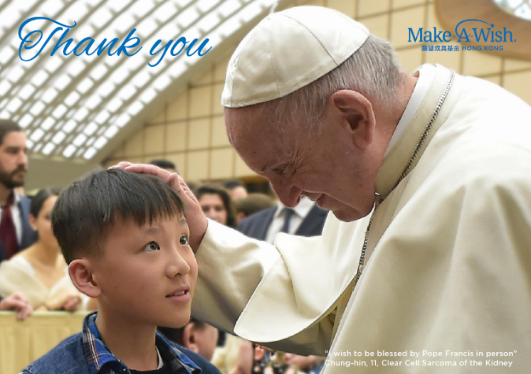

  你的相片 Your Photo

背面設計Back Design :

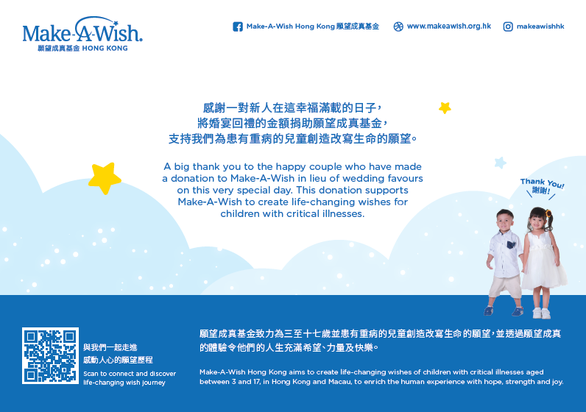

- 捐贈金額 Donation
賓客人數 No. of Guest | 數量 Quantity | 捐贈金額 Donation Amount  (*請選擇 Please select)
120人Guest (10圍 Table) | 120張pcs |    HK$2,888
180人Guest (15圍 Table) | 180張pcs |    HK$3,888
240人Guest (20圍 Table) | 240張pcs |    HK$4,888
300人Guest (25圍 Table) | 300張pcs |    HK$5,888
360人Guest (30圍 Table) | 360張pcs |    HK$6,888
以上 Or above | 1,000張pcs |    HK$8,000 或 Or    其他金額 Extra: ___________

- 領取方法 Collection
*請選擇 Please select:
  自取或請速遞到願望成真基金辦事處領取 Self-pick up or by courier
  速遞到付 Courier cash on delivery

收件人姓名 Name: ______________________
收件人電話 Contact no.: _________________
送貨地址 Delivery Address:
______________________________________________________
______________________________________________________
______________________________________________________
- 聯絡資料 Contact Information

姓名 Name: ___________________________ (中文) ____________________________ (English)

聯絡電話 Contact no.: _________________ 電郵 Email: _______________________________

地址 Address: _____________________________________________________________________

____________________________________________________________________________________

- 付款方法 Payment

  支票 By cheque

支票號碼 Cheque no.: __________________________________________________________

抬頭請寫:「願望成真基金有限公司」

Please make cheque payable to “Make-A-Wish Foundation of Hong Kong Limited”

  信用卡Credit Card (*請選擇Please select: VISA卡 VISA card/萬事達卡 Master Card)
持卡人姓名 Cardholder’s Name: _______________________________________
信用卡號碼 Credit Card No.: __________________________________________
有效日期 Expiry Date (月MM/年YY): __________________________________
持卡人簽署 Cardholder’s Signature: ____________________________________

  直接捐款 Direct Bank-in
匯豐銀行戶口號碼HSBC Bank Account No.004-042-1-056-243
渣打銀行戶口號碼Standard Chartered Bank Account No.003-447-1-664706-3
*請將數紙正本寄回本會︒Please mail the original bank-in slip to us.

備註 Remarks:
  願望成真基金將以上述資料與你保持聯絡，定期介紹本會的活動資訊及工作進展。如若你不願意收到有關資訊，請於方格內加上 “”號。 
  Make-A-Wish® Hong Kong may use your contact information from time to time to provide you the news of program, events and fundraising materials. If you do not wish to receive the information, please “”the box.

感謝你的支持! Thank you for your support!

